**VCS Task**

**Task Description:**

Establish a new directory, populate it with script files, initiate an empty repository on GitHub, convert the local directory into a Git repository, and link it to GitHub for pushing the code into the repository.Perform merge, rebase, stash commands in following github repo.

**Solution#**

Establish a directory with Script files

Convert local directory into Git repository

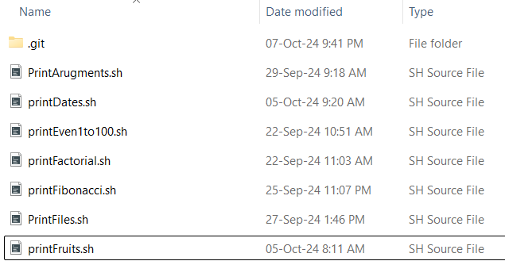

------------------------Code----------------------------------

git init

git add README.md

git commit -m "first commit"

git branch -M main

git remote add origin https://github.com/unjilani/VCS_assignment.git

git push -u origin main

git merge

git rebase

git stash

-----------------------------------------------------------

